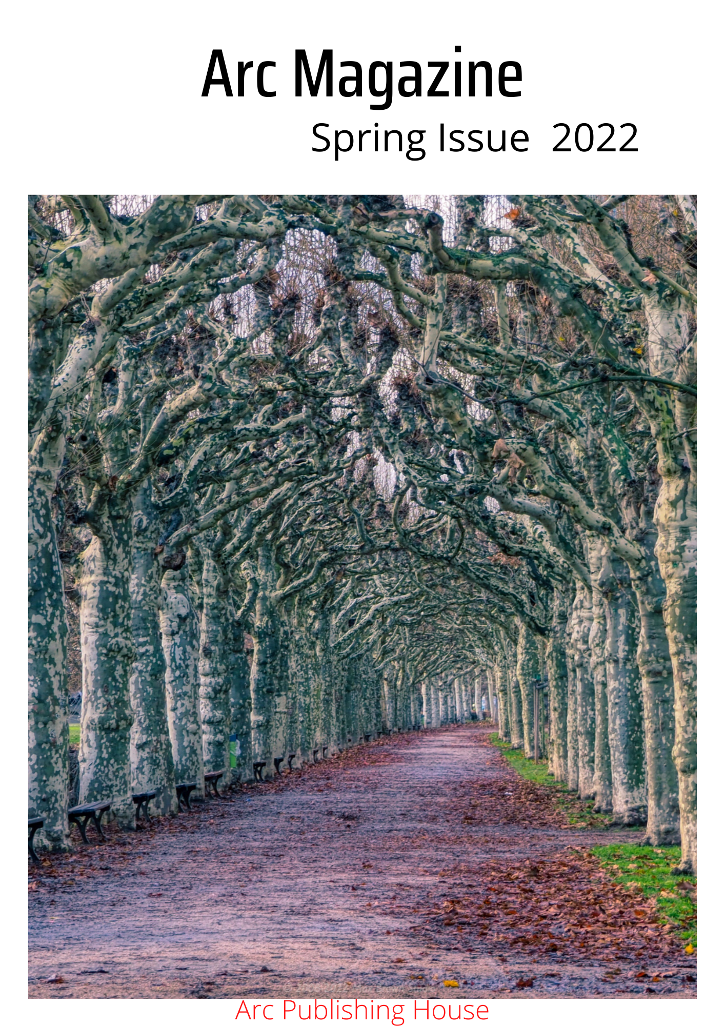

Arc Magazine

Spring Issue 2022
Editor Dr Pragya Suman

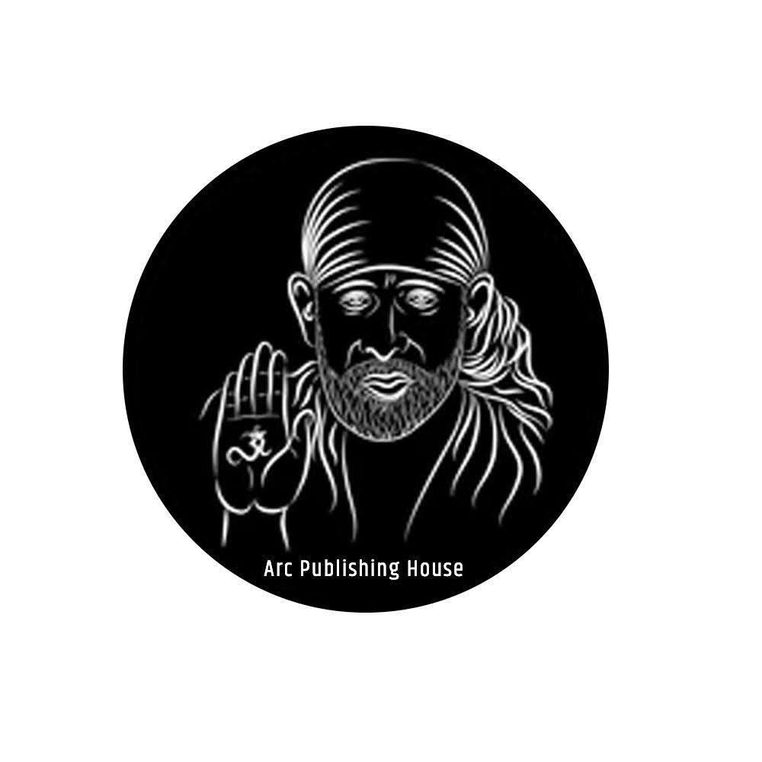



Editor’s Note
Dr Pragya Suman
Founding Editor
In India, February and March are spring seasons and according to Hindu Calendar, we call it Basant. A season of fresh blooms, and nature spreads its cheer and color in one of the most fantastic tones. Basant Panchami, is a Hindi word.
Basant means Spring
Panchami means the fifth day
On Basant Panchami, we celebrate the festival of Deity Saraswati, goddess of art and knowledge. I decided to make Arc trinary from this season and hope it would gain love and appreciation like past issues. Yesterday I compiled the final manuscript of the spring issue and its contributors have added bright hues in the background of spring. Much more like my garden which is lit up in the glaze of lily, marigold, rose, and petunia.
I have tried my best to make the spring copies pristine and lucid. In the spring issue, we have kept British Author Alice Hiller in the Featured Poet column. The sexual trauma she suffered in her childhood has manifested in her poetry poignantly. Her social activities on the platform of voicing our silence are thought-provoking. Alice’s debut book “Bird of Winter” is brilliant and neatly crafted in an experimental way.
The sparrow steps by Amanda Huggins, A Crate of Fortune Cookies by Adam Aitken, Negev 1976 travel poetry by Peter Green, experimental works by Gregory Betts, Shore Leaves by Donall Dempsey—an elegant example of personification, etc have added the limpid links of spring with crayons.
Here is a brighter garden
Where not a frost has been;
In its unfading flowers
I hear the bright bee hum:
Prithee, my brother,
Into my garden come!
Emily Dickinson
But Frost has not vanished now! The gruesome gates of war between Russia and Ukraine is pulsating the peace. Hope art would save the world and just peep above the walls –we all are drops of the same ocean.

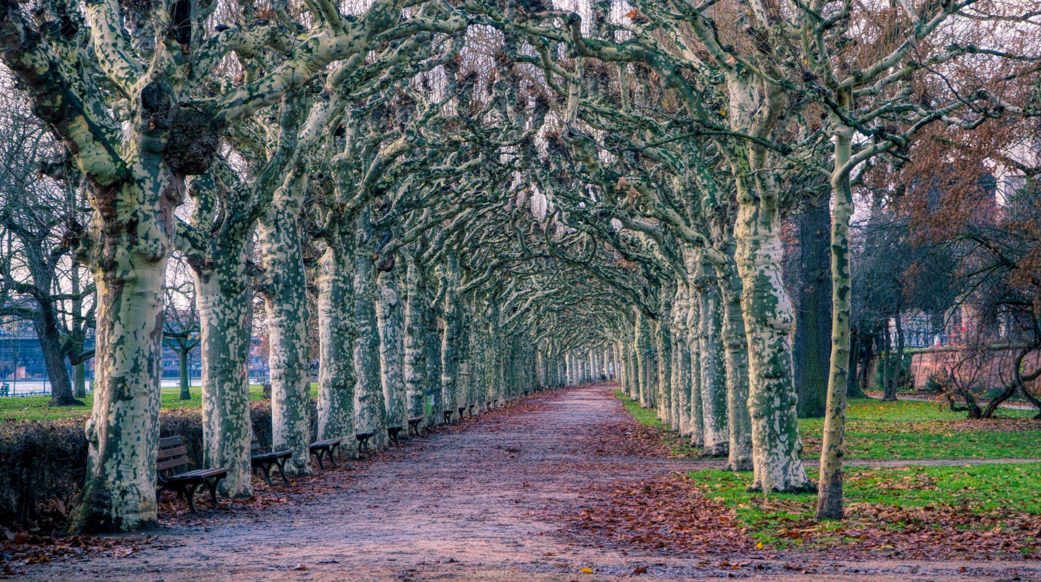

Front cover: ‘Frankfurt Trees’ is done by Photographer Max Brown. He lives in Valecia, Spain. About his art he says–
“I started photography when I was an architecture student in the early 1970s. As my career changed, I stopped my photography until 2008. When I retired in 2011, I started traveling extensively all over the world and found a new interesin travel photography.
‘Frankfurt Trees’ was taken in a park that follows the Am Rheim river though Frankfurt in the winter of 2018.”

Max Brown

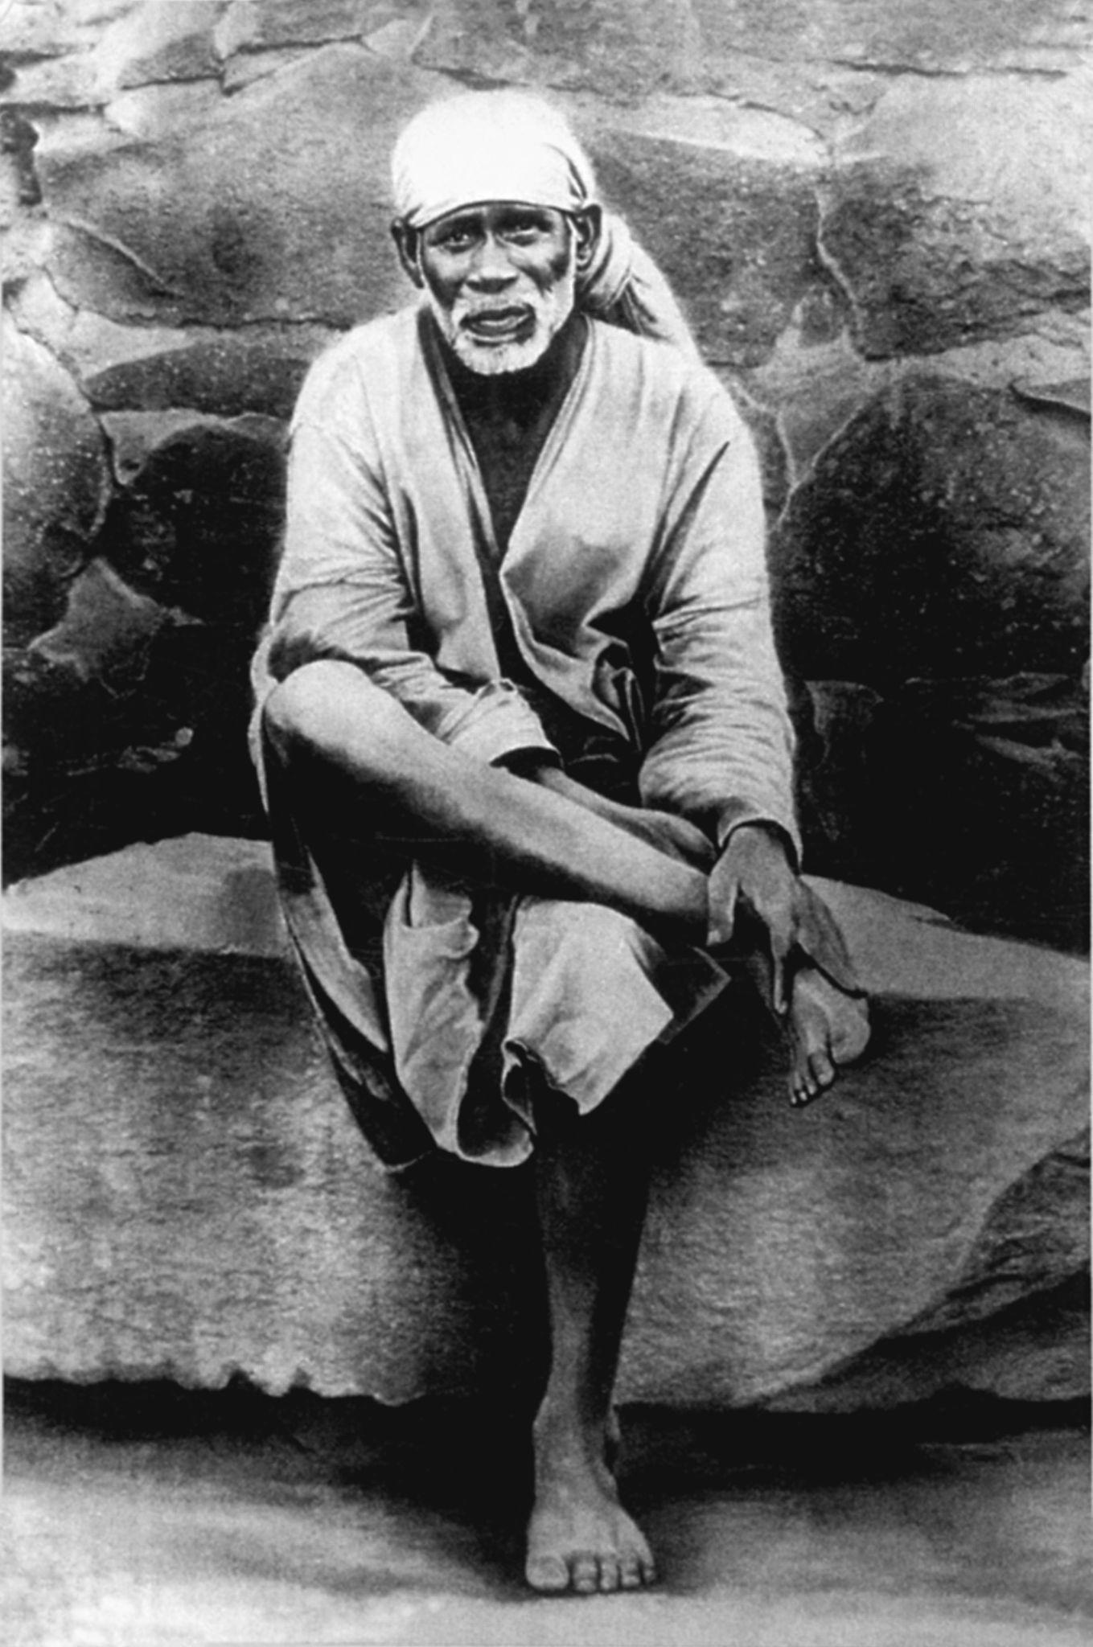 Shirdi Sai Baba was an Indian yogi, spiritual master.

Dr Pragya Suman

Shirdi and Plague

The pale fire has blackened the heaven and lord descended down in tattered fabric. A fakir was sitting in a mosque and the black demon hidden in bacilli was eating Shirdi. Plagued Shirdi was shivering.
Fakir likes to sleep in open eyes as devotees' tears have drowned him.

“My devotees are my breath and at once can inhale the whole visible.” Fakir told the birds.

He awakened and the stony mill began to move round and round in the hand of fakir. White wheat soaked all the demons in itself and crushed down on the mound. The long hand of the Lord gave wheat flour to devotees.

“Take it and spread it over the border. Soon the calamity is going to be over.”

"Listen I am Nirgun Bram and I will soon crush all your black burdens of the past."
"Keep faith in my child, my stony mill will go one."

Alice Hiller

Tessellation

from her bed in the white cloud alice watches the commode she uses
as a toilet it is three steps away but cannot be mentioned she has
not been allowed out of this room since she arrived pills drop her
into nothing at night and hollow out her days

the doctor asks if alice
is feeling better alice thinks about the menu cards they make her
fill within the leather armchair the doctor’s thighs spread warmed
marzipan alice says she is getting used to being here

the doctor’s
hair is pulled back into a bun she suggests that after alice leaves
hospital she could travel to the desert and learn arabic alice imagines
tents and camels and cushions with tiny mirrors
the doctor lights her
cheroot filling alice’s lungs with heavy candy floss the doctor says
you must understand you’re not your mother you can only get well if
you move far away from her
as the doctor speaks giant scissors
snip around the window once these scissors have cut all the way
round the frame alice rises up light as a leaf cold air is lifting her
out into the waiting sky

alice both physically and mentally is much
less depressed and more outgoing I think she
is beginning

letter, alice hiller medical notes, 1 november, 1977

Alice Hiller

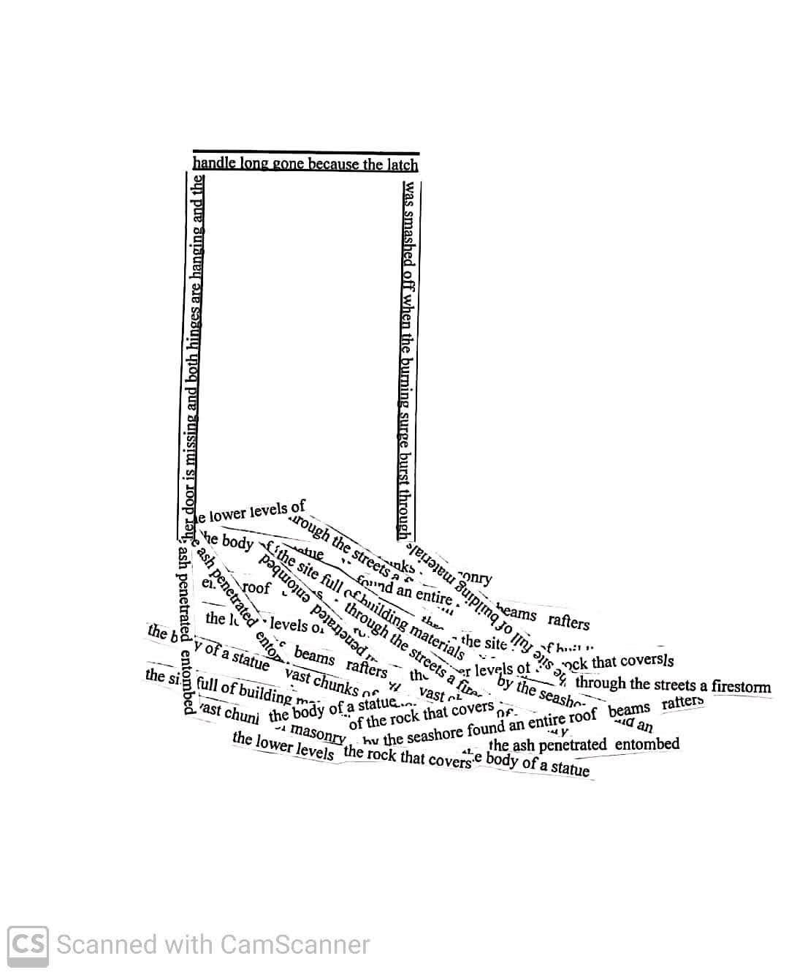
Alice Hiller

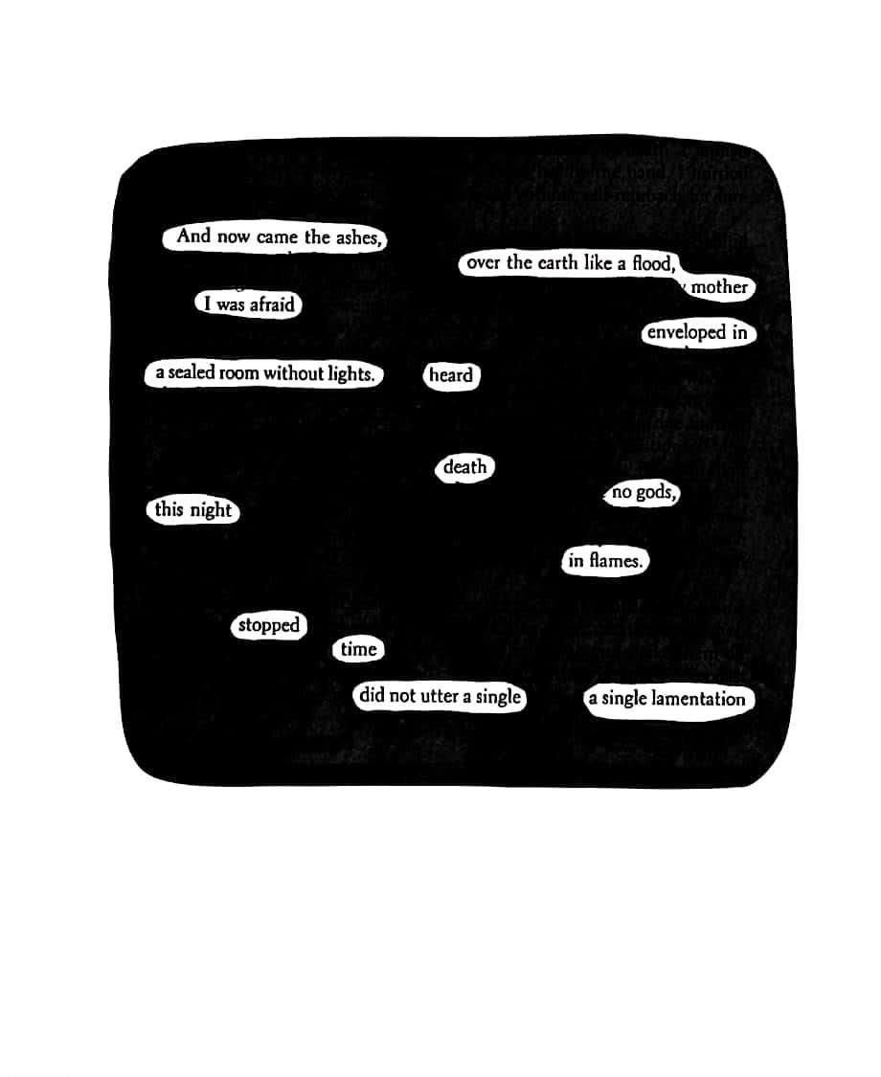

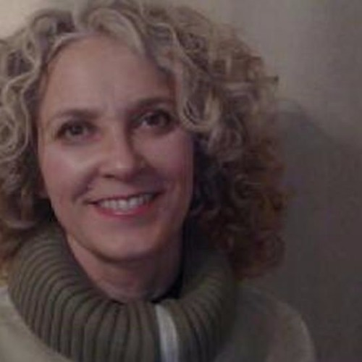

Featured Poet
Alice Hiller

When I was growing up during the 1970s, England experienced intensely cold winters. Walking through the graveyard of the parish church with my mother, I would sometimes find small birds lying curled in the snow. Seeking shelter within yew bushes, they had frozen to death overnight, then fallen from their perches. Although I could not articulate why at the time, the hunched shapes of their still, undefended bodies resonated with me.

During those same years of unlocking the church, polishing its brasses, singing hymns on Sundays beside my mother, I was also being subjected to penetrative sexual abuse by her. We had moved together to Wiltshire from Brussels when my father died, the year I turned eight. In the English countryside, surrounded by darkness and silence, my mother took me into her bed. I was not able to tell anyone what came to pass between us for two decades beyond the physical abuse ceasing.

Writing bird of winter in my fifties, which gives creative witness to this crime, also on behalf of the millions who are subjected to childhood sexual abuse around the world, I knew the poems needed to exist in relation to the white spaces around them. I wanted them to communicate at a somatic and an instinctive level, through the shapes they made on the page, as the birds’ hunched outlines in the snow connected with me to suggest my own body when I was word-less. I wanted the freedoms of more experimental poetry to open pathways to healing.

Working visually as well as texually in bird of winter, I invite the reader’s conscious and subconscious selves to collaborate dynamically in the work of ‘reading’, conferring upon them an agency that the abuse denied me. Through this they become discoverers, rather than recipients of this complex material, and participate in the collection’s journey into meaning and resolution. They can also calibrate their depth of engagement, as I hope these three featured poems reflect.

‘tesselation’, was named for the process of fitting mosaic tiles together to form a picture. Remembering a conversation with the psychiatrist who was treating me for anorexia when I was thirteen, its stanzas are nonetheless separated. This registers to the eye, how even as we present narratives around trauma, gaps inevitably remain.

The rapes at the heart of my being unable to speak lie within the erasure, ‘and now came the ashes’. Pliny’s account of the eruption of Vesuvius is a frame for my experience within my mother’s bed. How silencing may descend on an individual in the aftermath of a violent crime is present within the blacking out. White islands of words perform partial acts of recovery, while also embedding, through the lack of a clear sequential path forward from the midpoint, that this story cannot easily be told.

Finally, the concrete poem, ‘her door is missing’, combines my own words with found materials from a book about Herculaneum. This describes how the pyroclastic flow carried a mass of objects from doors to house beams to statues through the town. I wanted the empty doorframe to make visible how the crime of sexual abuse forcibly removes a child’s possibility of refusal and leaves them open to further, damaging predation.

PS: What is your opinion about late bloomers as you wrote your debut book in the fifties?
AH: I have been writing professionally all my adult life. I was a freelance journalist, wrote a factual book about the history of the t-shirt, researched a literary PhD, then wrote reviews, and other articles, before finally beginning to work on bird of winter the year I turned 50. My younger son leaving home, combined with being diagnosed with ovarian cancer in my late forties, freed me to address my childhood. Sometimes people with family responsibilities, or complex materials, need time and distance to be able to write safely about them.

PS: Tell me about your next book
AH: I am working on a memoir that holds the first eighteen years of my life.

PS: Do you view writing as a kind of spiritual practice?
AH: Yes. For me it requires a process of self-quietening, in order to be able to hear.
Whenwe write, we have the possibility of opening our individual experiences into a wider
communion – through the collaborations that art involves. As part of my writing process,
I walk with my dog, noticing the world around me, and also meditate, and swim, to help
tune in to whatever needs to emerge.

PS: What is your thought about experimental poetry? I read that your memoir incorporates fragments of poetry. What do you think about blending of the genre? AH: For me, art establishes channels for communication, between self and other, and past and present, as well as between individuals and made objects. The more facets we incorporate, the more entry points we create.

PS: Tell me about your project Voicing our Silences.
AH: Voicing our Silences is a workshop which I set up for people working creatively with complex or difficult materials. We support each other in developing our work. We now have around sixty members. We have a website which aims to offer this support beyond the group through recorded workshops.

'tesselation', 'her door is missing' and 'and now came the ashes are from bird of winter published by Pavilion Poetry and reproduced by kind permission of Liverpool University Press. To buy bird of winter as an ebook or printed text please follow this link:

https://voicingoursilences.com/
http://bit.ly/birdhiller

Gurpreet K. Khalsa

The Samosa Man

The samosa man steps
to the platform’s edge
and we exchange, my rupees
for a hot pastry through bars
of the train window
In the distance, brief dawn
glimpses: rows of sugar cane,
bright green fields;
carts rumble along rutted paths,
laundry hangs on strings,
chickens peck in dusty yards.

I glance at the life;
the train moves on.

Oz Hardwick

Spin

Beyond insomnia is invisibility, hiding in plain sight, sliding in moonlight; not even specks flecked in bright, wide-open eyes. This is our best life, running without encumbrance through star-stunned streets, twin vexatious breezes flipping heads and tails, heads and tails. We sail like detuned fiddles, wailing at windows where nothing but spider-cracked glass separates winter from summer and the picture book city from the bottom of the sea. We’re sleight of sight, a hallucination of shopkeepers with loss leaders stacked high as teetering clouds and free gifts falling from the pages of kids’ comics and Sunday magazines. Beyond invisibility is incandescence, and we burn like Bengal matches in the dawn-dazzle chill, brief and blazing, as piano keys turn, unlocking the swooning tune of our reborn bodies relearning space.

Amanda Huggins

songs of leaving

There is a photo somewhere,
long since misplaced,
perhaps marking a forgotten recipe
or buried at the back of a bedroom drawer:
you, sprawled out on the picnic rug,
pale curls tangled in sunshine;
me, leaning forward, hugging my knees,
grin as wide as a Cheshire cat.

I tasted warm beer on your lips that day,
glimpsed the end of summer
darting between copper-bright trees,
sunlight slipping slowly
behind blue-grained hills
as the band sang their songs of leaving.

And in the morning, parch-mouthed, bones
aching, clothes damp with dew,
you pulled nubs of twig, a dead moth,
the skeletons of leaves
from your hair.
Then you smiled,
and the music spun me round again
as though it had never ended.

Amanda Huggins

the sparrow steps

Did you ever think about that afternoon in Kamikochi,
dry twigs snapping underfoot?
I held out the skeleton of a cherry leaf,
told you autumn was proof that death could be beautiful.

You lagged behind as we climbed the hill,
paused at the top, out of breath.
I laughed, said we were getting older,
but I remember now that you didn’t reply.

We stopped at a bridge and you sat on the steps,
unfastened your boot to shake out a stone.
I crouched beside you, watched you run your fingers
over a row of tiny imprints in the concrete.
These birds’ feet are proof, you said,
that we sometimes leave an eternal mark,
that we live on after our beautiful deaths.

We should make a pledge, I replied,
if we ever lose touch we’ll meet here,
at the sparrow steps, ten years from today?
It was an easy promise, I was so sure we’d never be apart.
You looked up at the cherry trees,
and for a moment I remembered them in spring.
Then I saw the uncertainty in your eyes.
Yes, you said, quietly, we must do that.

Amanda Huggins

at the kitchen table

The late spring snow
catches us off-guard,
drifts against the henhouse wall,
blots out the distant fells.

And here, in this borrowed house,
we watch, transfixed,
brave the blizzard
to throw scraps for the birds,
half-wishing it could always be like this.

Just you and I
at the kitchen table—
a dog-eared novel,
the weekend papers,
the last bottle of wine
waiting on the shelf
until the sheep are fed.

Yet we know
the snow will thaw by morning,
and we’ll drive down the lane
for bread and logs,
ice-melt from the trees
pattering on the bonnet.

Then, too soon,
the workday grind will call us back
from this adopted life
to the small house in the town,
where everything is a little less bright
and a little less kind.

As we leave,
the weather will change again,
the brilliant shine of it
making us smile,
and I’ll point out a newborn lamb,
his pink ears backlit by the sun,
as he watches us drive away.

Peter Green

Negev, 1976
Stumbling in our sandals,
assailed by waves of heat
through the Negev Desert,
we meet a portly and taciturn man:
head of an agricultural kibbutz;
colleague of a teacher friend
in Scotland. Struggle to communicate
with him ( the fractured conversation
turns into a linguistic nightmare )
until finally we move on- in mutual
incomprehension- and reach a blessed
oasis; a shimmering lake; a diadem
of ice on a brutal afternoon.

Cautious still of its fathomless depth
we dive in, wincing at the cold.
My mood is one of exhilaration
combined with fear that my heart
will stop, and my soul will remain
submerged in the green lake
in a foreign country for ever more.
Doggy paddling, struggling to swim,
I crawl towards the rocks and clamber
out like a slug. Rest my body and
jump in again, ignoring my brother's
protestations, my heart hammering
like a wild animal in my rib cage.

Three trucks of army soldiers join us:
Amazonian women dressed in green
fatigues; fit and tanned, all with rifles
and we chat, amicably enough,
through the long afternoon, under
the ancient sky, while the girls dive
like seals or mermaids, waiting for
their callow teenage victims.
Ramachandran MA

October Sunset

east window-
how many moons
in the courtyard?

October sunset-
how many sunsets
in me, father?

how long have you been
here in the air, father?

who is murmuring it
tonight in my ears, father?

over the eastern hill
full moon tonight-
where could you go
in an evening like this
my father? - nowhere
yes, nowhere but here

who has been murmuring
something in the dark?
perhaps the wind
yes, perhaps the wind

over the still water
full moon in October

whose shadows are meeting
there in our old lane-
where you trod long
where once I trod
perhaps no one, father
perhaps no one-

Gregory Betts

Wazrd Search

a b c d e f g h I j k l m n o p q r s t u v w x y z

Gregory Betts

Wxyrd Search

a b c d e f g h i j k l m n o p q r s t u v w x y z
a b c d e f g h i j k l m n o p q r s t u v w x y z
a b c d e f g h i j k l m n o p q r s t u v w x y z
a b c d e f g h i j k l m n o p q r s t u v w x y z
a b c d e f g h i j k l m n o p q r s t u v w x y z
a b c d e f g h i j k l m n o p q r s t u v w x y z
a b c d e f g h i j k l m n o p q r s t u v w x y z
a b c d e f g h i j k l m n o p q r s t u v w x y z
a b c d e f g h i j k l m n o p q r s t u v w x y z
a b c d e f g h i j k l m n o p q r s t u v w x y z
a b c d e f g h i j k l m n o p q r s t u v w x y z
a b c d e f g h i j k l m n o p q r s t u v w x y z
a b c d e f g h i j k l m n o p q r s t u v w x y z
a b c d e f g h i j k l m n o p q r s t u v w x y z
a b c d e f g h i j k l m n o p q r s t u v w x y z
a b c d e f g h i j k l m n o p q r s t u v w x y z
a b c d e f g h i j k l m n o p q r s t u v w x y z
a b c d e f g h i j k l m n o p q r s t u v w x y z
a b c d e f g h i j k l m n o p q r s t u v w x y z
a b c d e f g h i j k l m n o p q r s t u v w x y z
a b c d e f g h i j k l m n o p q r s t u v w x y z
a b c d e f g h i j k l m n o p q r s t u v w x y z
a b c d e f g h i j k l m n o p q r s t u v w x y z
a b c d e f g h i j k l m n o p q r s t u v w x y z
a b c d e f g h i j k l m n o p q r s t u v w x y z
a b c d e f g h i j k l m n o p q r s t u v w x y z

Gregory Betts

Werd Search

q w e r t y u i o p
a s d f g h j k l
z x c v b n m

Maurice Devitt

February

To remind me of the spelling
I would silently emphasise the ‘ru’,
a short, secluded pause,
before enunciating individual letters,
a trick I also found useful
for Wednesday and calendar:
exaggerated pronunciation of ‘nes’
and the assertive stamp of ‘dar’
allowing me to unfurl the words
in seamless order. I’m not sure
if the teacher heard this hesitation
and whether it afforded her
a momentary gap,
for the clinking mechanics
of her own childhood learning
to slip into view.

Maurice Devitt

The train driver

who lives next door
has been known to talk in his sleep,
reciting timetables to his wife,
eyes blinking faster
when they enter a tunnel.
He sits up suddenly in bed,
cries out as the wardrobe
hurtles towards him,
his legs straightening
against the footboard as he brakes,
frame sparking and screeching
to a halt, yards from a boy
who used to bully him at school,
scared eyes piercing the night.

Donall Dempsey

SHORE LEAVE

the sea louder in the dark
throwing off its shackles
walking into town

mystified seagulls
flying over with a caw
a sea no longer there

a tram screeching
on its points
the sea jumps aboard

the sea sat at the bar
somehow getting its vast bulk
perched upon a high stool

the sea enjoying the karaoke
singing along to The Honeydippers
eating bag after bag of peanuts

"Have ye no beds to go home to!"
barks a barman
his belly slopping over his belt

the sea happy
to escape itself
even for the time being

drunk on being
human if only for a while
the sea staggers back to the shore

Vik Shirley

Split

An egg hatched and a Polish Lowland Sheepdog, who insisted on telling the most boring story anyone had ever heard, emerged.

After 17 excruciating minutes, he was put down.

Whilst expiring he gave birth to a 17th century Russian streltsy, who was so anxious that he made everyone else in the room feel unbearably awkward.

In 8 minutes, 40 seconds, he was put down too.

As he took his dying breath, a miniature majorette marched out of his mouth, twirling and throwing her baton in the air, whilst whistling an upbeat version of Foreigner's, 'I Want to Know What Love Is'.

The audience was split on this one. So they cut her in half, exterminated one half, but not the other.

Her living half mated with half a semi-professional tap-dancer, whose performance had also divided the gallery, and gave birth to a high-class male escort, who had talons for ears.

The audience found this amusing, but a tad contrived. At that moment the executioner's back opened and a quail flew out. The audience reached for their guns, shot it and spent the rest of the afternoon taking pictures of the corpse.

Anwer Ghani
Pink Sound
I didn't feel sleepy at the time, but I did smell the dreamy floral scent from the pink sound. Do you see the celebration of colored fields? Its fragrant spirit is the scent of ecstasy that envelops the eyelids. When your eyes see the majestic pink sound waves, at that time you will remember my words, and you will feel the distant carnival lands in my scattered corners. Yes, I have not smelled the sleeping flowers, but I am a skilled farmer who knows all about his dreamy smile and hidden desires.

Ivan Peledov

Waiting for a Snowfall

This time of the year
centaurs don’t hide in the grass anymore,
trees are playing an ancient game
using the Sun for a ball,
crows are all for body modification,
their new shapes
allow them to reach the Moon.
Every name seems to be misspelled,
endless fences perplex sky dwellers,
clouds desperately try to listen to mice,
the smells of celestial dictionaries
send them off course.

Ivan Peledov

Wordless

Few in the kingdom desire the dregs of the future.
Fallen leaves inundate the world
and clog the souls of the prophets.
Guardian angels and other beasts
relentlessly lick the sky and wall calendars
made before walls were invented.
They know the days of creation were mute.

Ivan Peledov

Laughing Stock

While the police were worried about
vile rituals at the edge of the solar system,
I was stealing trapdoors and manhole covers
here on earth, in my hometown.
Disguised as a pile of quarters and dimes
or a scream of a child caught by a tree,
I failed to call passing clouds by their names.
Animals sent to the void above
must have mocked my cheesy imagination.

Adam Aitken

A Crate of Fortune Cookies

Look - how this instrument predicts the death of prediction.

The evenings it projects
are long and calm as summer solstice.

What the instrument predicts,
is longer and calmer than it ever was
before the birth of the Instrument.

The sun will rise, like a head
sticking up over a parapet.
The instrument predicts this.

Before you, it sees
unquantifiable risk.

Your world, as the instrument says, will spin
ever slower than we can dance.

Dance then, quicker and more anxiously
around the ash of what was once our fire.

Dial up the radiator full blast.
Watch for the poisoned inbox.

A new North Wind will freeze-dry the frontier.

Pull tight the shawl across your shoulders.
For they will arrive, the painted warriors.

With their Instrument they
prepare the oracle, consult the lunar planting calendar.

When Venus enters Scorpio add your Scarab to the broth.

On the waxing moon the fringe dwellers shall emerge
to pick wild thyme and procreate
in the shade of a revered tractor.

Go there with this Instrument
and you will receive gratification.

On the 27th day of Leo a lawyer must disinfect your paperwork.

On the 28th cost-effectively analyze your risk profile,

On the 28th re-tune your spectra.

In Autumn the planets will line up with the agents.
In Hanoi they will steal your bike, as the Guide warns.
Do not be distracted by a waiter.

In Dili the market’s cornered by Australian spies
– advise you invest in build-for-rent teepees
in the shadow-state of the infamous.

In Shenzhen you can still make a million and take up Scotch.

Do morning mantra for damage control.
Prepare for tediously long graduation.
Inspiration costs will rise.
Continue to punctuate - your enemies
will respect and fear your rigour.

Allow some fat and other sacrifices
to migrate past the frontier.

Mark each decoy with a code.

Any day now, my friend, our plotters will arrive.
They’ll be looking for the last surviving palm reader.

Avoid all offers of pickled cabbage.
Recycle everything in multiples of three.

At some point live in the moment,
but not just now.

Alison Lock

nurture

step
into a puddle of sky
lean into the ripples
touch the bark of oak
describe a carved heart
follow the sign of an arrow
gather the veined leaf
of horse-chestnut
in the palm of your hand
plant your soles deep
in silence
look up to the umbrella
of webs how the canopy
absorbs the ether
Earth holds you safe
as roots embrace

Feby Joseph

Postcards from Dammam

Sun looms supreme in sands frozen in time
Barely moving – it lays down, arms and all
Defeated and prostrate – the world around
Liquid silver mirage; flying Dutchman of desert.

The distant calls of a minaret dividing the silence –
Gentle call – Allah… divine and pure as the sands
And only the sands can carry that call to Him.
Still lies the desert, gateway to heaven.

At dusk, city-children of the Bedouin heed the calls
Of their forefathers; drive their four-wheelers
Off the modern tar roads into a blue, lazy desert
To step into the past once again in large tents.

Deep in the desert a tribe settles in – air rich with
With the scent of sweet tea and rice and roasting meat;
Still music of a serene Oud strumming gratitude
And thousand echoes of Bi-smi llāh perfuming a night.

Feby Joseph

A family Portrait in December

A Mumbai December is a curious beast –
Like an October child that never quite grows
It carries the ubiquitous heat through in sharp contrast
To the snow filled Christmas movies I watch on my laptop.

My father smiles perennially through a sheen of dust
As if that is the only emotion he ever mastered,
Keeping in rhythm of the climatic status quo
As an unseasonable Satie tinkles in the background…

My mother cocoons herself into another evening
In the velvety words of television theologists
(There’s nothing new to report there!)
As I shut the door to another Alleluia; Another evening.

My brother connects, once again through social media
To share images of cute foxes and owls.
And we reminiscent and laugh on borrowed anecdotes
As a spider weaves on the elephant tusk hanging on the wall.

Kamrul Islam

An Image, Carved On Twilight's Symphony

When I remember you, I remember the nightingale floating in the sea light, the gust of winds under the cloudy sky, the ravings of your soul.

Your twisted eyes lost in the wild doves groom the tune of disintegration, the upsurge signalling our artistry somewhat blind, an image, carved on twilight's symphony.

As far as I remember the old kisses, my childhood soaked in weeds clinging to distant fields where
Krishna Kaberi, the daughter of Jatin, walking through the ashes of cremation.

She was an extraordinary spread of simple pendulums,
As far as I remember, I keep floating
Like a humble devotion in the tears of a trapped pigeon--

Laszio Aranyl

The Ancestors

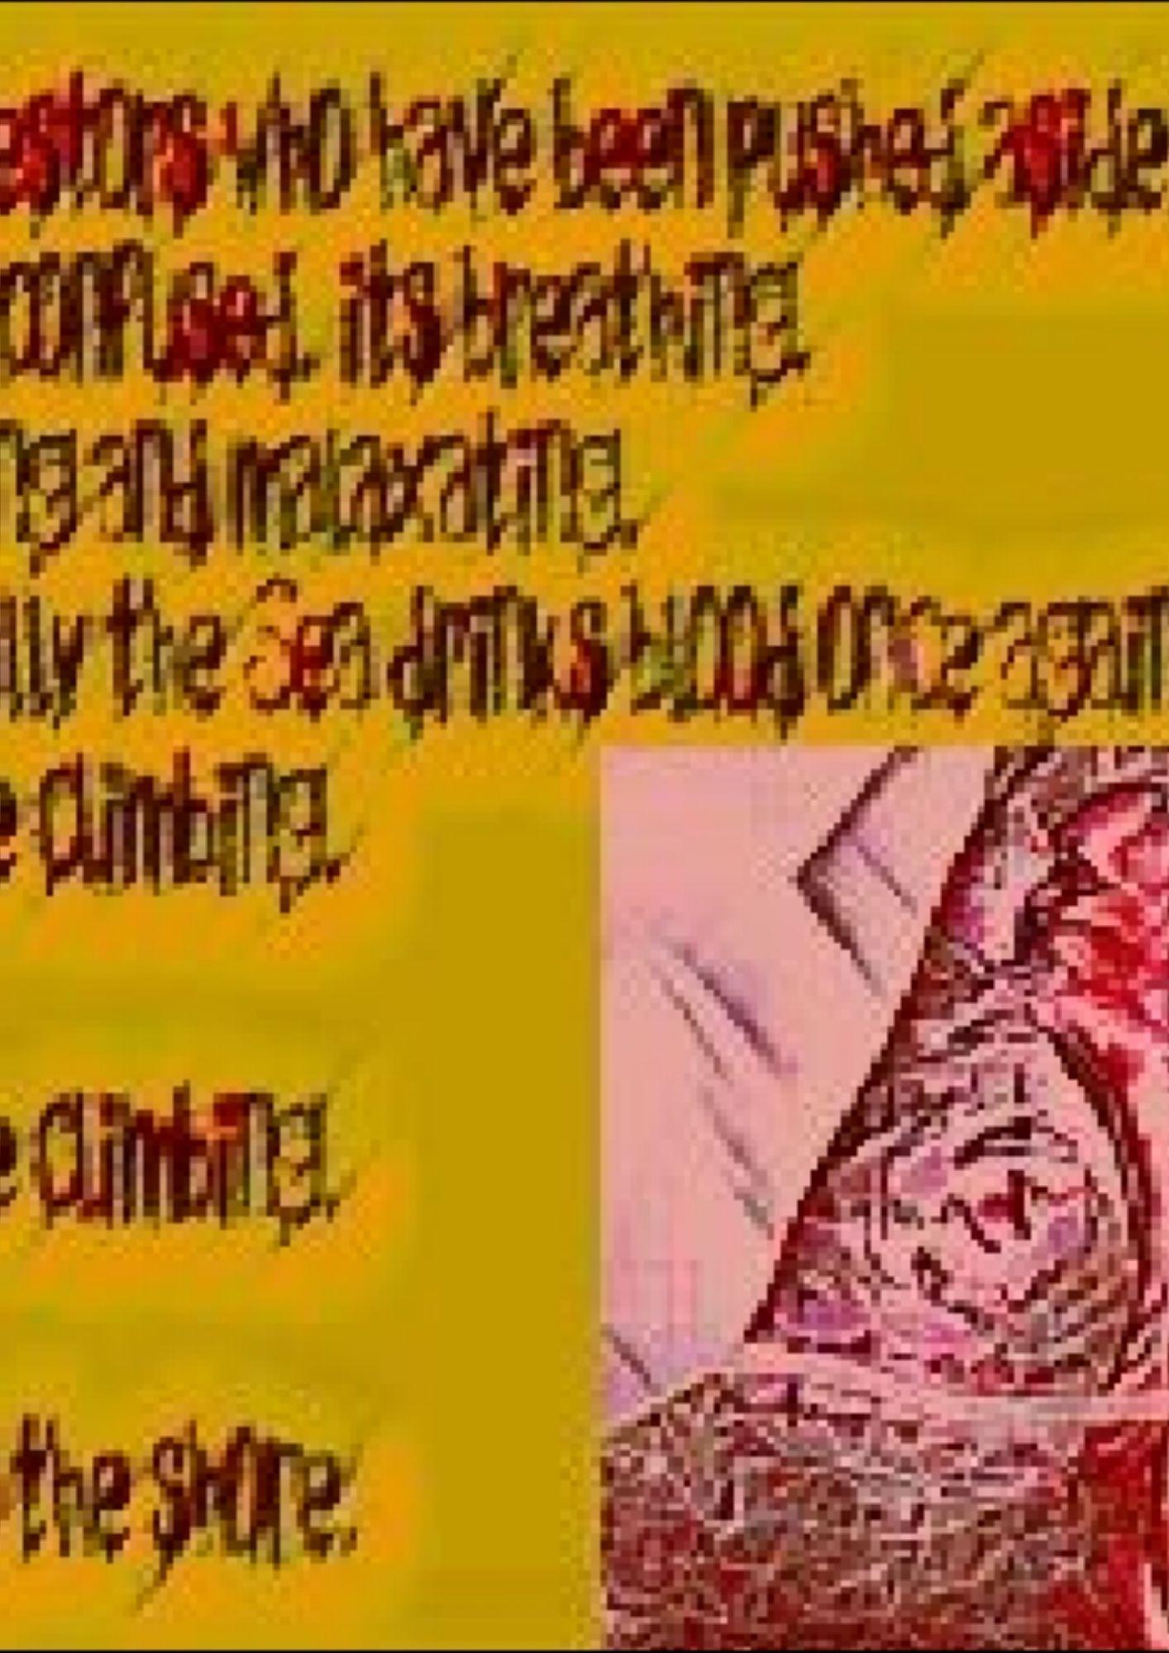

Contributors:--

Alice hiller is a writer from London and Dieppe. Her debut poetry collection, 'bird of winter', is published by Liverpool University Press, 2021 and was chosen as the Summer Special Commendation by the Poetry Book Society. Written with reference to her childhood medical notes, the poems witness to alice's experience of being groomed and sexually abused as a child during the 1970s, and then making a creative life beyond this. Author of The T-Shirt Book (Ebury Press), alice also holds a PhD from UCL. Her journalism, reviews and poems have been widely published. She interviews poets about ‘saying the difficult thing’ on her alicehiller.info blog and was shortlisted for the Arts Foundation Poetry Fellowship in 2019. As part of her commitment to change through creativity, hiller founded and runs a free poetry workshop aimed at supporting and developing poets working with ‘less welcome’ materials. This led to the www.voicingoursilences.com website.
Gurupreet K. Khalsa is a current resident of Mobile, Alabama, USA, having lived previously in Ohio, Washington State, India, New Mexico, and California. She holds a Ph.D. in Instructional Design and is a part time instructor in graduate education programs. Her work has appeared in The Poet, TL;DR Press, New York Quarterly, Far Side Review, Necro Productions, IHRAF Publishers, aurora journal, Last Leaves, Delta Poetry Review, Ricochet Review, Pure Slush, and other online and print publications. Several poems have won awards.
Oz Hardwick is a York-based writer, photographer and musician, who has been published extensively worldwide, and has read everywhere from Glastonbury Festival to New York, via countless back rooms of pubs. His chapbook Learning to Have Lost (IPSI/Recent Work, 2018) was the winning poetry collection in the 2019 Rubery International Book Awards. His latest collections are the chapbook The Lithium Codex (Hedgehog Poetry Press, 2019), and the experimental prose poetry micro-novella Wolf Planet (Hedgehog Poetry Press, 2020) .By day, Oz is Professor of English and Programme Leader for English and Writing at Leeds Trinity University.
Amanda Huggins is the author of the novellas All Our Squandered Beauty and Crossing the Lines, as well as five collections of short stories and poetry. She has won numerous awards, including two Saboteur Awards for poetry and fiction, the Colm Toibin International Short Story Award 2020 and the H E Bates Short Story Prize 2021. She was also a runner-up in the Costa Short Story Award 2018 and the Fish Short Story Prize 2021, and has been shortlisted for the Bridport Prize, The Alpine Fellowship Award and many others. Amanda lives in Yorkshire and works in publishing.
Maurice Devitt is past winner of the Trocaire/Poetry Ireland and Poems for Patience competitions, he published his debut collection, ‘Growing Up in Colour’, with Doire Press in 2018. Curator of the Irish Centre for Poetry Studies site, his Pushcart-nominated poem, ‘The Lion Tamer Dreams of Office Work’, was the title poem of an anthology published by Hibernian Writers in 2015.
Dónall Dempsey was born in the Curragh of Kildare, Ireland, and was Ireland’s first Poet in Residence in a secondary school. He has read on Irish radio and appeared on TV there. He moved to London in 1986 and has continued to write and perform his poetry ever since. He is well known for his dynamic delivery when reading, his surreal imagery and his tenderness, a poet in love with the world. Dónall’s poetry has been published in numerous magazines, anthologies and journals, both online and in print. He has published five collections, Sifting Shape into Sound, Being Dragged Across the Carpet by the Cat, The Smell of Purple in 2013, and Gerry Sweeney’s Mammy, and Crawling Out and Falling Up, the fifth, which was published in November 2020.
Gregory Betts is an experimental poet with collections published in Canada, the United States, Australia, and Ireland. He is most acknowledged for If Language (2005), the world’s first collection of paragraph-length anagrams, and The Others Raisd in Me (2009), 150 poems carved out of Shakespeare’s sonnet 150. His other books explore conceptual, collaborative, and concrete poetics. He has performed these works hundreds of times, in many countries, including at the 2010 Vancouver Olympic Games as part of the "Cultural Olympiad.” He is a professor of Canadian and Avant-Garde Literature at Brock University, where he has produced two of the most exhaustive academic studies of avant-garde writing in Canada, Avant-Garde Canadian Literature: The Early Manifestations (2013) and Finding Nothing: The VanGardes, 1959-1975 (2020), both with University of Toronto Press. He is the President of the Association of Canadian College and University Teachers of English (ACCUTE), curator of the bpNichol.ca Digital Archive, and Associate Director of the Social Justice Research Initiative. His most recent book is Foundry (2021), a collection of visual poems inspired by a font named after a 15th century poet. He lives in St. Catharines, Ontario.
Vik Shirley's chapbook Corpses (Sublunary Editions) was published in 2020. Her collection The Continued Closure of the Blue Door (HVTN Press), her book of photo-poetry Disrupted Blue and other poems on Polaroid (Hesterglock Press), and her pamphlet Grotesquerie for the Apocalypse (Beir Bua Press) were published in 2021. Her work has appeared in such places as Poetry London, The Rialto, Magma, 3am Magazine, Shearsman and Tentacular. She edits Mercurius magazine's 'Surreal-Absurd', is Associate Editor of Sublunary Editions, and is currently studying for a PhD in Dark Humour and the Surreal at the University of Birmingham.
Anwer Ghani is an award winner poet from Iraq. He was born in 1973 in Babylon. His name has appeared in more than fifty literary magazines and twenty anthologies in USA, UK and Asia and he has won many prizes; one of them is the "World Laureate-Best Poet in 2017 from WNWU". In 2018 he was nominated to Adelaide Award for poetry and in 2019 he is the winner of Rock Pebbles Literary Award and the award of United Spirit of Writers Academy for Poetry. Anwer is a religious scholar and consultant nephrologist and the author of more than eighty books; thirteenth of them are in English like; “Narratolyric writing”; (2016),“Antipoetic Poems”;( 2017) and "Mosaicked Poems"; (2018), and “The Styles of Poetry”; 2019.
Ivan Peledov lives in Colorado. His poems have been published in Artifact Nouveau, Unlikely Stories, Sonic Boom, Eunoia Review, and other magazines. He is the author of the book Habits of Totems (Impspired, 2021).
Adam Aitken was born in London and lives in Sydney. He spent his early childhood in Thailand and Malaysia. He has been a recipient of the Australia Council Paris Studio Residency, and was Visiting Distinguished Professor at the University of Hawai’i Manoa. He co-edited the Contemporary Asian Australian Poets anthology (Puncher & Wattmann). His memoir One Hundred Letters Home (Vagabond Press) was published in 2016 and was listed for the ASAL gold medal. Archipelago, his latest collection of poetry, was shortlisted for the Kenneth Slessor Award and the Prime Minister’s Literature Prize in 2018. He teaches Creative Writing at the University of Technology Sydney.
He is winner of Patric white award 2021.
Alison Lock writes poetry, short fiction, and creative non-fiction – the author of two short story collections, four collections of poetry, and a novella. Her work has been published in many literary magazines, and broadcast on BBC Radio 3. Her poetry collections are: A Slither of Air (2011), Beyond Wings (2015), Revealing the Odour of Earth (2017), and Lure (2020). Her work focuses on the relationship of humans and the environment, connecting an inner world with a love of nature through poetry and prose.
Peter Green is an author from Scotland. By profession he is teacher.
Feby Joseph ia from the beautiful South Indian state of Kerala, he describes himself as a spiritual vagabond. He is currently working as a Piano teacher in Mumbai. Feby is the winner of Reuel International Prize, Poetry, 2020. Some of his works have appeared on Café Dissensus, Foreign Literary Journal and The Bangalore Review.
Kamrul Islam is poet and essayist from Bangladesh. He is chairman of the Board of Intermediate and Secondary Education.
Laszlo Aranyi (Frater Azmon) poet, anarchist, occultist from Hungary. Earlier books: (szellem)válaszok, A Nap és Holderők egyensúlya . New: Kiterített rókabőr. English poems published: Quail Bell Magazine, Lumin Journal, Moonchild Magazine, Scum Gentry Magazine, Pussy Magic, The Zen Space, Crêpe & Penn, Briars Lit, Acclamation Point, Truly U, Sage Cigarettes Magazine, Lots of Light Literary Foundation, Honey Mag, Theta Wave, Re-side, Cape Magazine, Neuro Logical, The Daily Drunk Mag, Unpublishable Zine, Melbourne Culture Corner, Beir Bua Journal, Crown & Pen, Dead Fern Press, Coven Poetry Journal, Journal of Erato, Lothlorien Poetry Journal, Spillover Magazine, Punk Noir, Nymphs Literary Journal, Synchronized Chaos, Impspired Magazine, Fugitives & Futurists, The Dope Fiend Daily, Mausoleum Press, Nine Magazines, Thanks Hun, Downtown Archive, Hearth & Coffin Literary Journal, Our Poetry Archive (OPA), Juniper Literary Magazine, Feral Dove Magazine, Alternate Route, CENTRE FOR EXPERIMENTAL ONTOLOGY, Bullshit Lit Magazine, Misery tourism, Terror House Press, Journal of Expressive Writing, APOCALYPSE CONFIDENTIAL, All Ears (India), Rhodora Magazine (India), Utsanga (Italy), Postscript Magazine (United Arab Emirates), The International Zine Project (France), Swala Tribe Magazine (Rwanda), The QuillS Journal (Nigeria). Known spiritualist mediums, art and explores the relationship between magic.
M.A. Ramachandran is a poet currently based in Kozhikode. He writes under his pseudonym Tekisui RC as well. Ramachandran’s poems have appeared in various journals and anthologies. Apart from poetry he is interested in farming, travelling and in the works of master filmmakers. He finds a little money for living by occasional teaching.

